
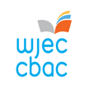

WELSH BACCALAUREATE
Advanced

Enterprise and Employability Challenge
Welsh Blood Service
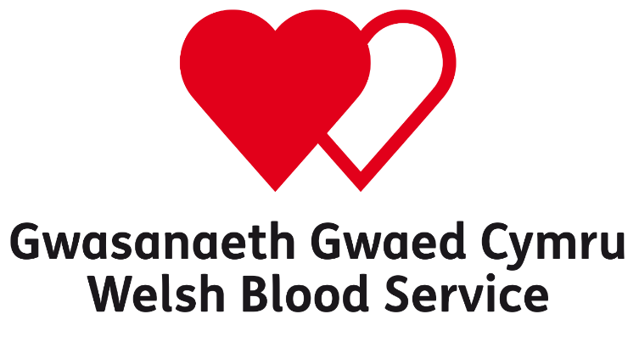

Available for assessment from February 2020

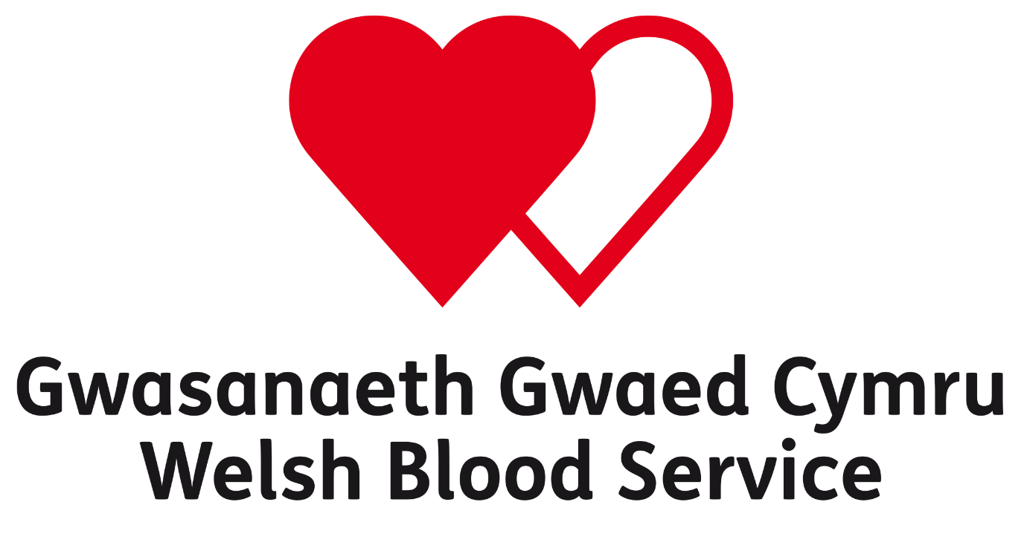
Encouraging more young blood, platelet and bone marrow donors

PURPOSE

The purpose of the Enterprise and Employability Challenge is to develop learners’ skills, whilst providing opportunities for learners to develop enterprising skills and attributes and enhance employability. During the Enterprise and Employability Challenge learners will explicitly develop skills in Numeracy, Digital Literacy, Creativity and Innovation and Personal Effectiveness and apply them in an appropriate manner.

BRIEF

Blood donation saves lives, every blood donation can help save or improve the lives of up to three patients in need.
Each year the Welsh Blood Service (WBS) needs to collect 100,000 donations in order to maintain blood product supplies to the 19 hospitals it supports across the country.
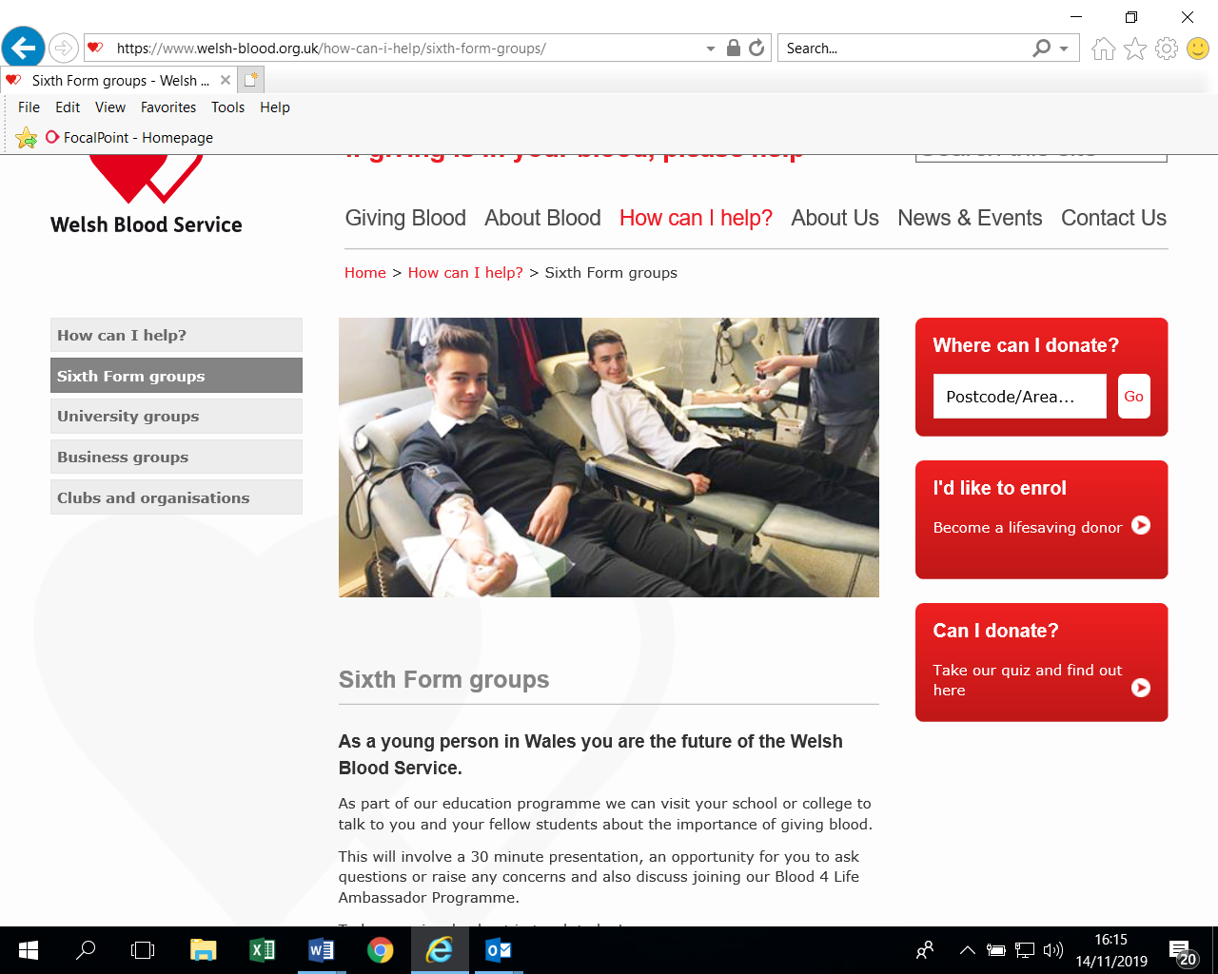
Each donation of ’whole blood’ can be separated and used as red cells, platelets and plasma.
Red cells can be stored for 35 days, the cells are used to treat conditions such as anaemia.
Platelets can be stored for up to seven days and act as a clotting agent to help prevent bleeding, which is helpful to patients with diseases or result of treatment for cancer and leukaemia.
Fresh-frozen plasma can be stored for up to two years and is used to treat patients with burns or heavy blood loss.
In order to meet hospital demand for donations, the WBS wants to ensure that young people understand the importance of and how to become a blood, platelet and/or bone marrow donor.
Your objective is to support the WBS in doing this by encouraging young people in your community and across Wales to better understand the importance of blood, platelet and/or bone marrow donations, resulting in more young people giving blood at their local clinics. Blood donors aged between 17-30 can also sign up to the bone marrow register.
As an individual or in a team (consisting of 3 – 6 members) your challenge is to design and develop digital promotional material/tools that will assist WBS to attract more young people to donate blood, platelets and/or bone marrow. You will need to be creative and innovative whilst developing your ideas, which will have to engage the target audience on the importance of blood donation. This will provide you an opportunity to develop and demonstrate a wide range of skills, qualities and attributes.
You will research and develop your own knowledge and understanding of the need for more blood donations and the work of the WBS. Over a period of at least 8 weeks, you will develop an Innovation Proposal and creative Presentation, that you will then present to a panel. The WBS will need evidence of who you are and what you have invented therefore you must register at the email address below.
By creating your digital Destination Passport you will be able to gather and showcase the skills, attributes, experiences and qualifications higher education and employers are looking for. By focusing on your future ambitions you can tailor the Destination Passport to match your career aspirations.

RESOURCES www.welshblood.org.uk/WelshBacc
CONTACT DETAILS Wbs.communitypartnership@wales.nhs.uk

